Macro/Close up Photography AWQ 4MI
Description
The goal of this unit is to use macro (close-up) techniques to produce TWO striking photographs of different subjects to get crisp, clear, 1:1 or larger images. You can shoot outside of class time or use the mini studio set-up in class using the backdrops and lighting provided.

Requirements
You will submit TWO close up photos, shot in JPG format (edited in Adobe Camera Raw) into your hand in folder by the assigned due date. You may use your camera's Macro setting or a macro lens if you have one. Other ways to capture macro images include:

- Shooting through a magnifying glass or a pair of reading glasses
- Shooting through a drop of water

No matter which method you use, ALWAYS use a tripod or a monopod to steady your camera.

Notes
Some great locations to find macro subjects:
- Your back yard
- Botanical gardens
- A local nursery (with permission of course)
- Local flower store (bring some flowers to your mother or grandmother!)

Macro photography isn’t limited to flowers or plants as subjects. Effective close-up subjects can range from antiques to a rusted door of an old car. It’s all in the composition.

Alternative places to look for macro subjects:
- Your junk drawer
- Antique stores
- Second-hand stores
- Dollar stores
- Your garage
- Any "special collections" you may have (coins, dolls, rubber bands, ...)
- Your kitchen

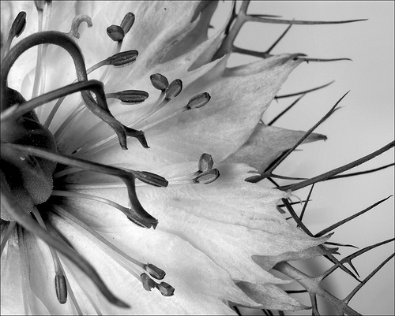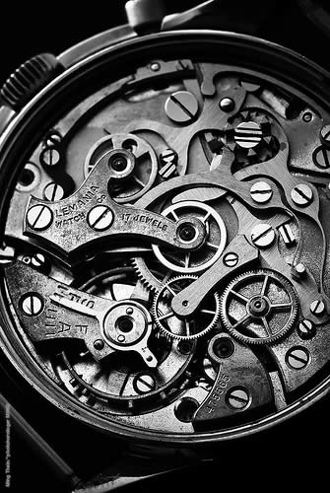
http://digitalphotographysecrets.com/digital-photography-tips-techniques/macro-photography/macro-photography-ideas-2/

