Creative Photography AWQ 4MI
Description
The goal of this unit is to take a variety of creative photographs inspired from trends happening in the photography world today. Decide what you want to express about your subject and how you can artistically express it using your shooting skills and editing techniques discussed in class. Even though, in some cases, you are incorporating images that have already been captured, you are still creating a new image in its own right. So be creative! Be bold! Be different!

Requirements
You will submit *Five (5) edited Creative Photos into your hand in folder. You must create five separate sub folders titled: Dear Photograph, alphabet, painting, perspective, and neoplasticim. You must include larger/printable (high resolution) files as well as all original, unedited photos by the assigned due date.

- A “Dear Photograph”- photo within a photo (with a written caption)
- A photo inspired by the alphabet
- A photo inspired by a painting (*include an image of the original painting and the works cited)
- A photo that plays with perspective
- A Neoplasticism inspired photo

In order to effectively complete this unit, you will need to complete the planning chart below. Weather will be factor when determining shooting days, but bring your camera to class every day. Consider your location, appropriate lighting techniques, alignment, and finishing techniques you will need to use in Photoshop when taking your pictures. Attempt to use a variety of finishing techniques such as vignettes, black and white, spot colour, panorama, and HDR.
Please ensure that you have proper model releases for any person present in your photo.

Photo #1 Example:
Create a “Dear Photograph” or photo within a photo. Inspired by Kitchener native, Taylor Jones, you will create a single exposure photograph of yourself holding an old photograph, taken in its original location. The goal is to compose a new photograph juxtaposing the old subject and background into the present. You can finish this photo using colour, black and white, or a combination of the two. Add a one line caption that begins with ‘Dear photograph’.
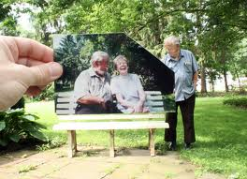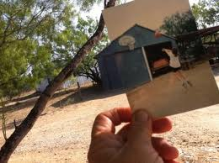
Dear photograph, Dear photograph,
Thank you for everything we had! I drained 3’s all day!
Jonathan Stampf Janet

Photo #2 Example:
Photo inspired by the alphabet – Niagara Falls, ON photographer Jennifer Blakeley has made a successful business using the alphabet as one of her inspirations for photography. Your goal is to create one word (minimum five letters) using a variety of objects and architecture. Black and white finishing is recommended to help unify the final piece. You will use Photoshop to create a single photo with a black border to create visual space between the letters, which will also help to emphasize the word.

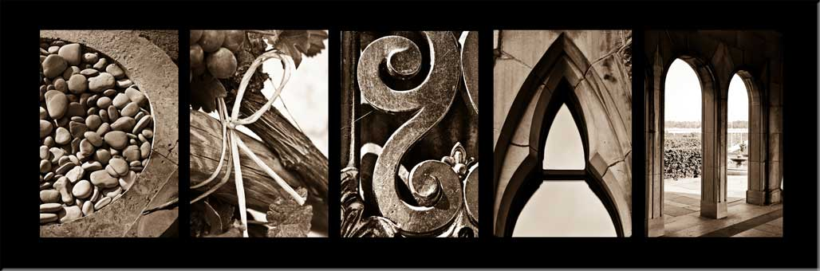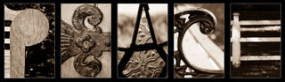

Photo #3 Example:
Photo inspired by a famous painting – Choose a famous painting to recreate in a photograph. Consider background, lighting, camera angle, props, costumes, and models. You do not have to duplicate every detail perfectly; it is your artistic interpretation of the painting that matters most.
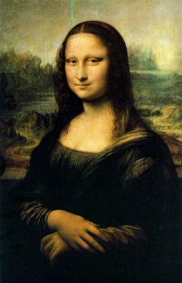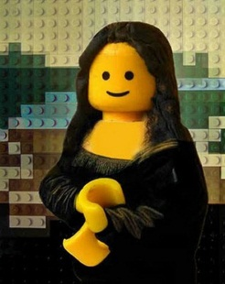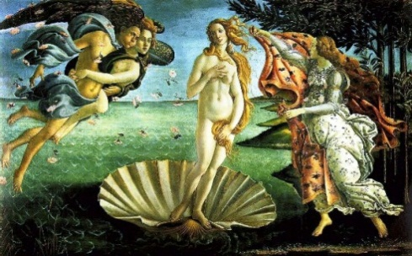
The Mona Lisa by DaVinci Sandro Boticelli, “The Birth of Venus” c. 1485-86

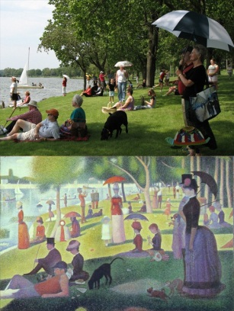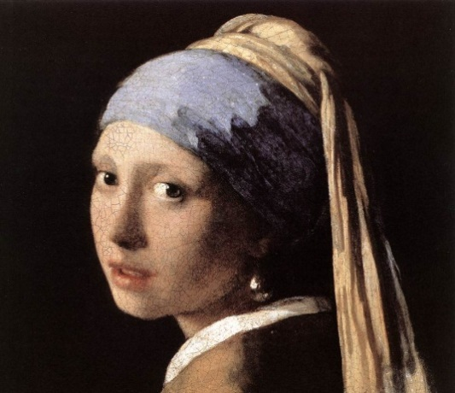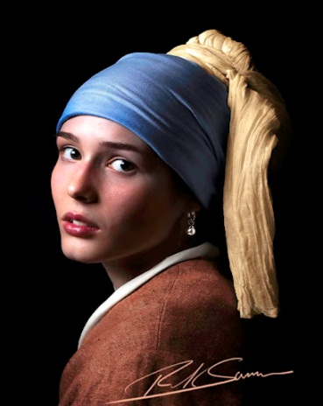
Saturday afternoon in the park Girl With a Pearl Earring by Johannes Vermeer
George Surrat

Photo #4 Example
Photo that plays with perspective – Your goal is to effectively use scale/proportion with two or more unlikely objects in order to create an optical illusion in one single exposure image. Visit the following blog to check out more examples for inspiration.
http://photographicblog.com/25-imaginitive-forced-perspective-photos-you-should-see/

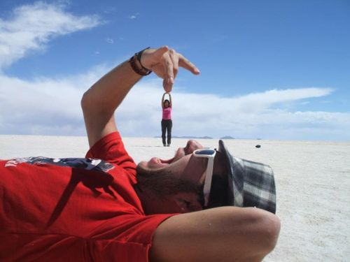

Photo #5 Example:
De Stijl (/də ˈstaɪl/, Dutch for "The Style", also known as neoplasticism, was a Dutch artistic movement founded in 1917. In a narrower sense, the term De Stijl is used to refer to a body of work from 1917 to 1931 founded in the Netherlands. The group's principal members were the painters Piet Mondrian (1872–1944), Vilmos Huszár (1884–1960), and Bart van der Leck (1876–1958), and the architects Gerrit Rietveld (1888–1964), Robert van 't Hoff (1887–1979), and J.J.P. Oud (1890–1963). The artistic philosophy that formed a basis for the group's work is known as neoplasticism — the new plastic art (or Nieuwe Beelding in Dutch).
This style expresses a new utopian ideal of spiritual harmony and order. They advocated pure abstraction and universality by a reduction to the essentials of form and colour; they simplified visual compositions to the vertical and horizontal directions, and used only primary colors along with black and white.
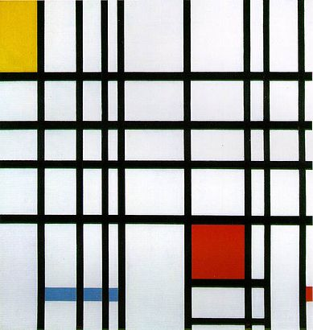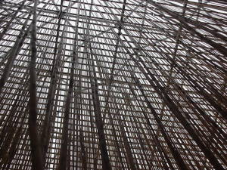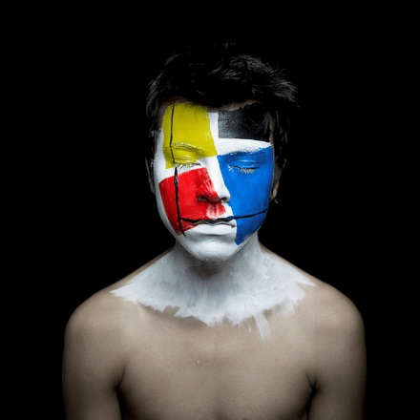
Piet Mondrian Unknown Face Artists – Neoplasticism by
Andy Alcala

Planning Notes
Put into practice the elements and principles of design, as well as compositional guidelines, focus, and exposure. You must have a plan before shooting, so jot down some notes below to help put your plans into action.

Photo within a Photo | Photo inspired by a painting | Photo inspired by the alphabet | Photo that plays with perspective | Neoplasticism

